**Installation Guide:**

* ***Software Requirement.***

***- MSSQL 2012.***

* **INSTALL MSSQL 2012.**

Run file setup.exe:

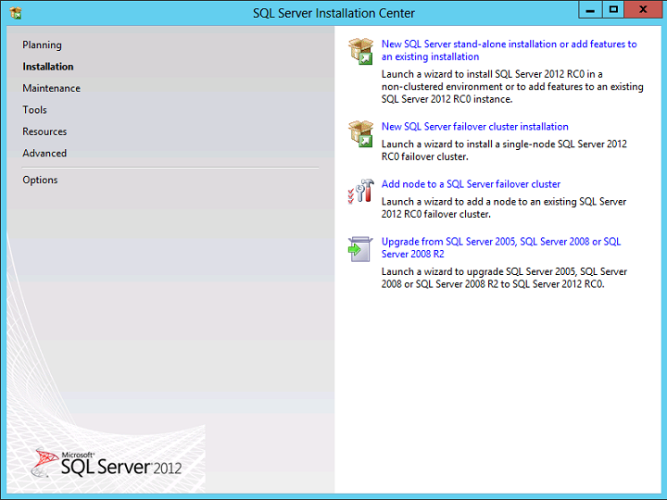

After choose " New SQL Server stand-alone installation or add features to an existing installation.

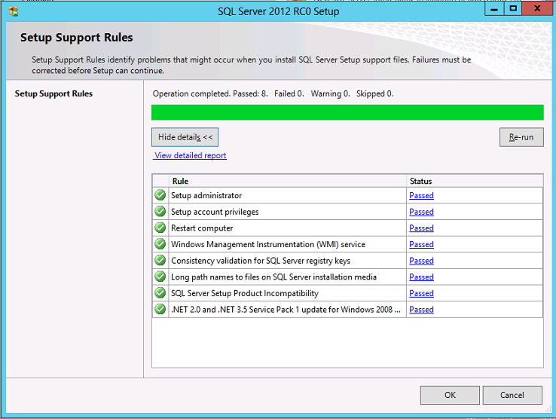

Wait s minute for check. After choose next, the screen will display as:

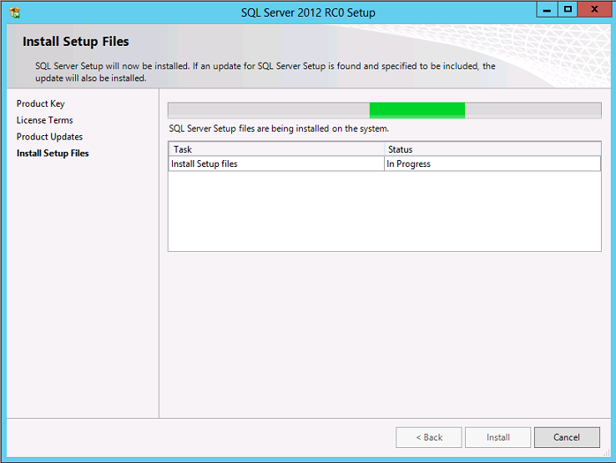

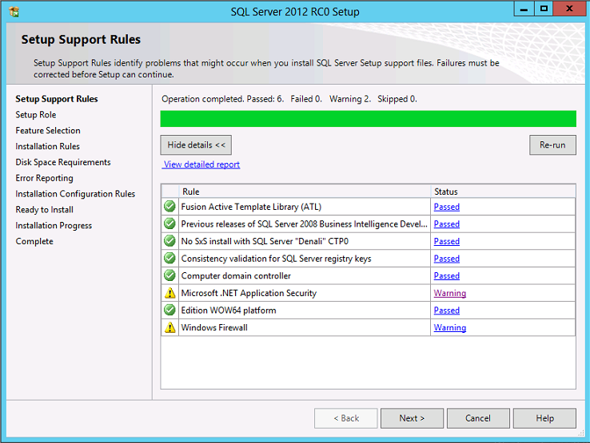

Click "Next".

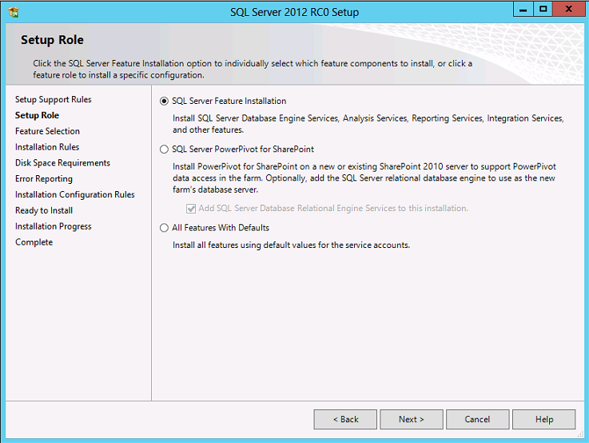

Click"Next" and you can check all the features hereafter.

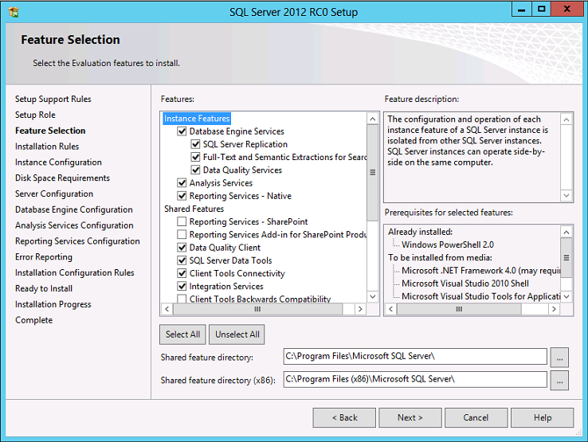

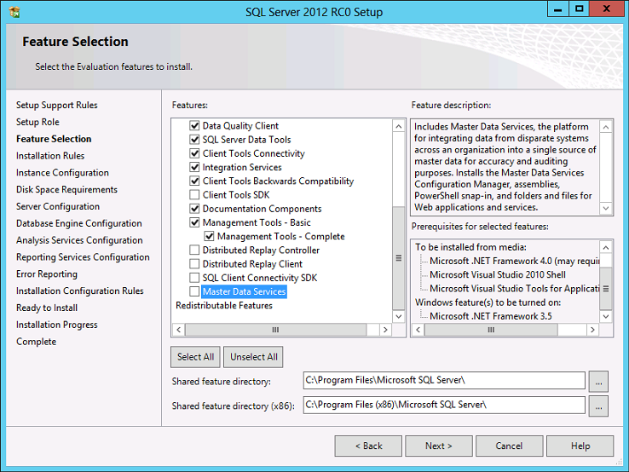

Click "Next" and "Next".

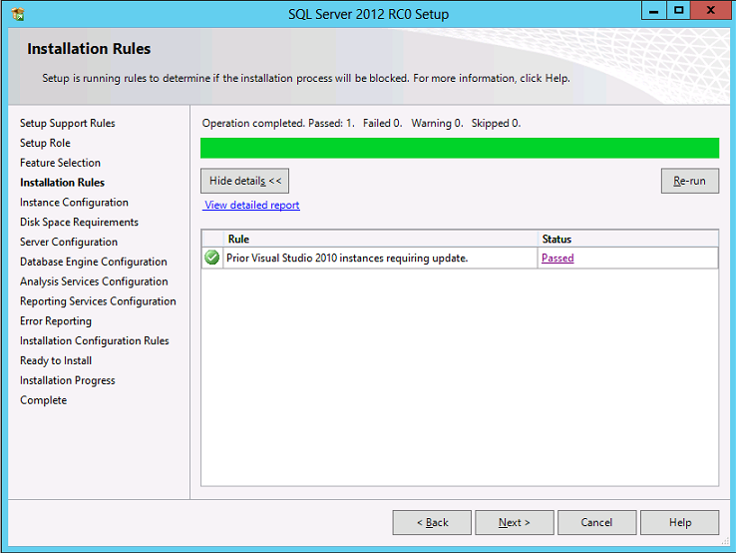

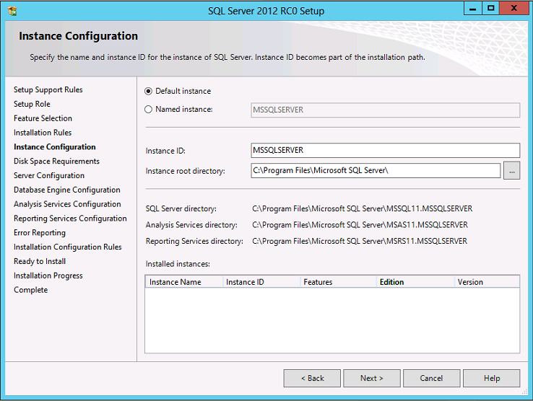

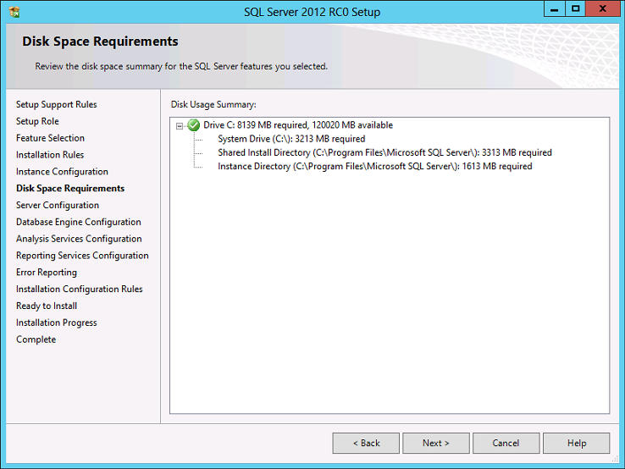

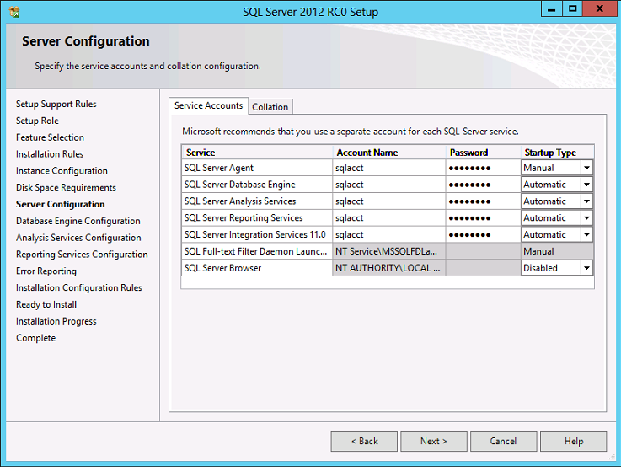

*NOTE :

- The next, screen will appear the two options :

+ Windows Authentication mode.

+ Mixed mode (SQL Server authentication and Windows authentication ).

- If you choose Windows Authentication mode , when you open up to log SQL Server , you must select Windows Authentication and SQL Server will automatically retrieve your Windows Account to sign in.

- If you select Mixed Mode ( SQL authentication and Window authentication), you will automatically creat a SQL Server login password. Its default username is " sa".

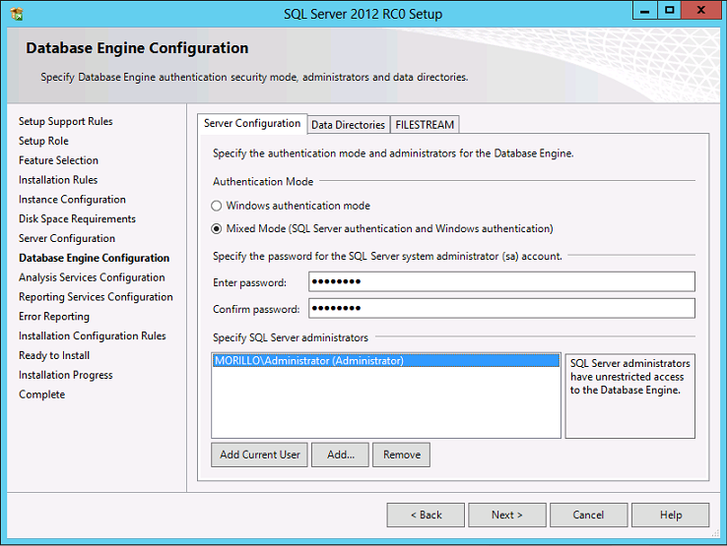

Click "Next".

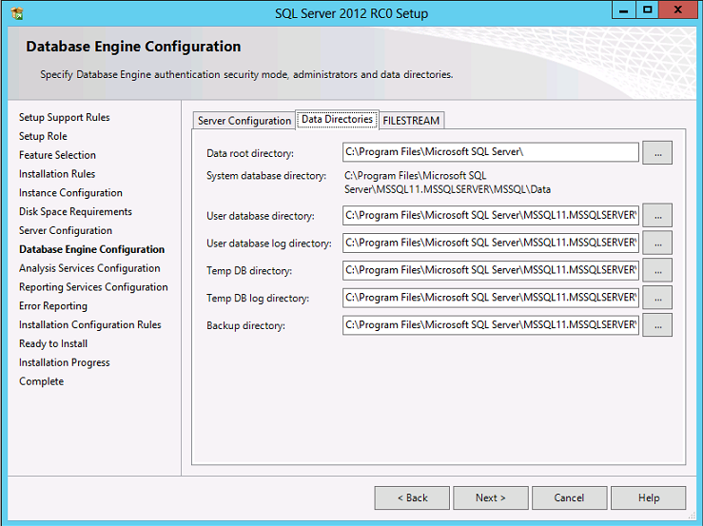

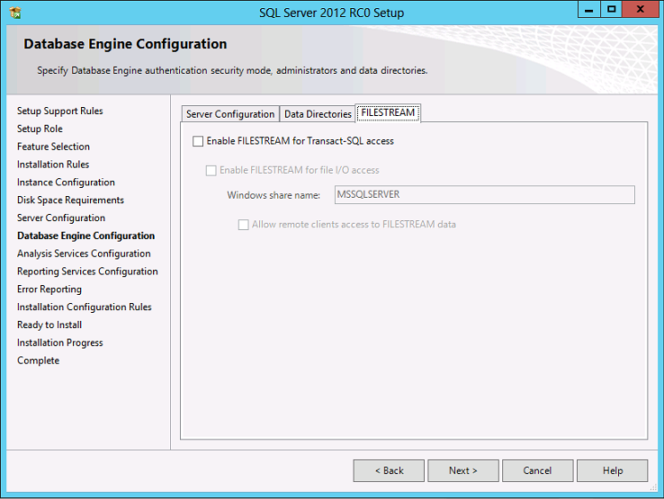

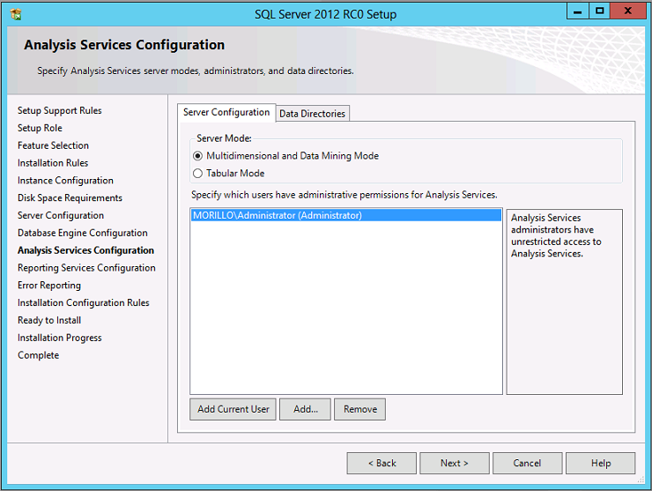

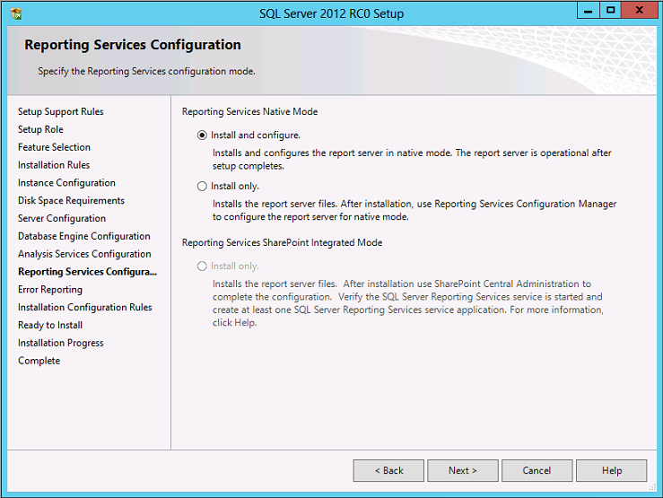

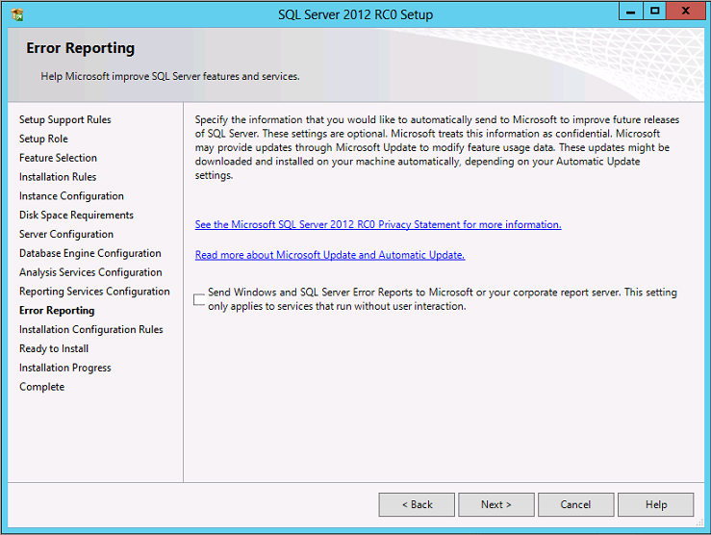

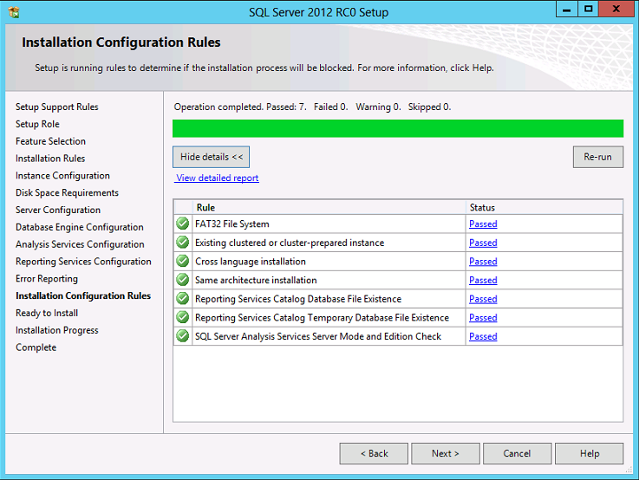

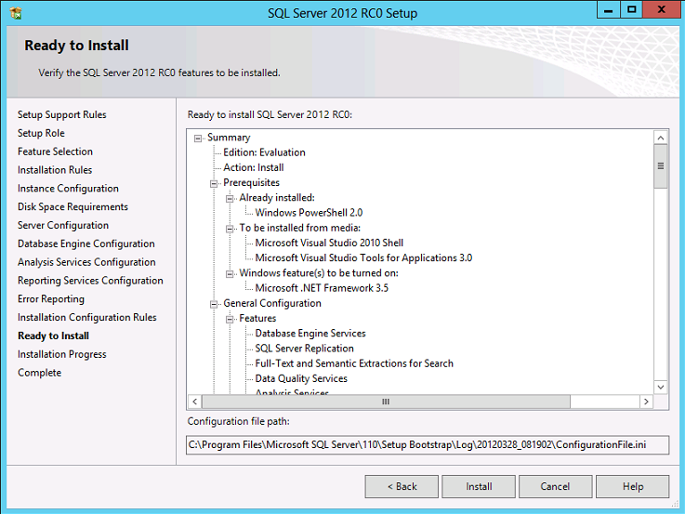

Click "Install" and wait a minute for setup.

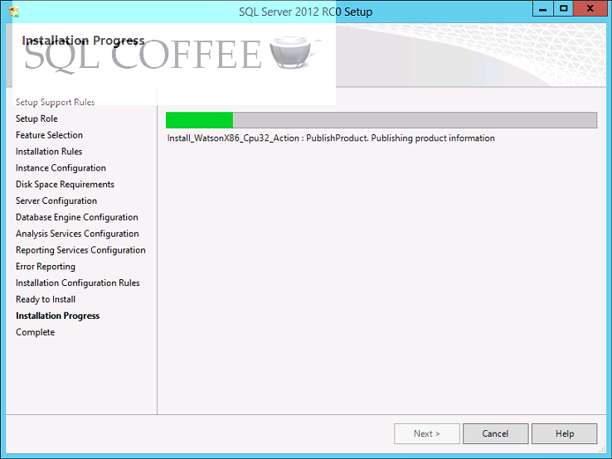

**2.1 Connect SQL**

* + Run SQL Server Management Studio

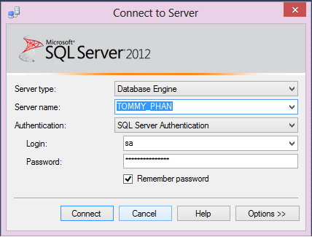

* + Open folder **eproject4** -> Open folder Resource-> Database--> Select file **script.sql** and then click Open

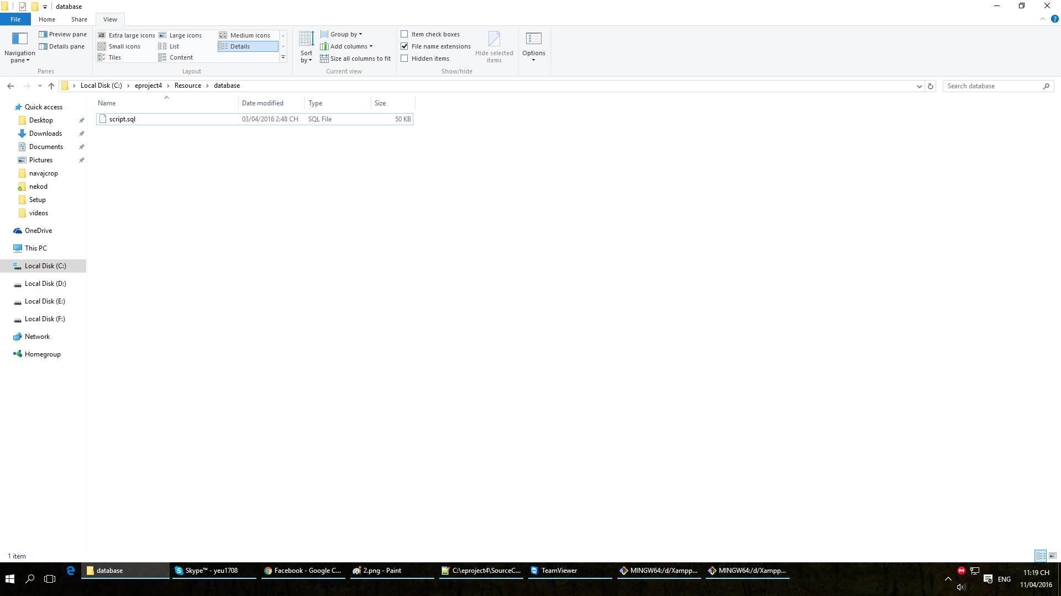

* File **script.sql** will be opened, then **CTRL + A** or **Excute.**

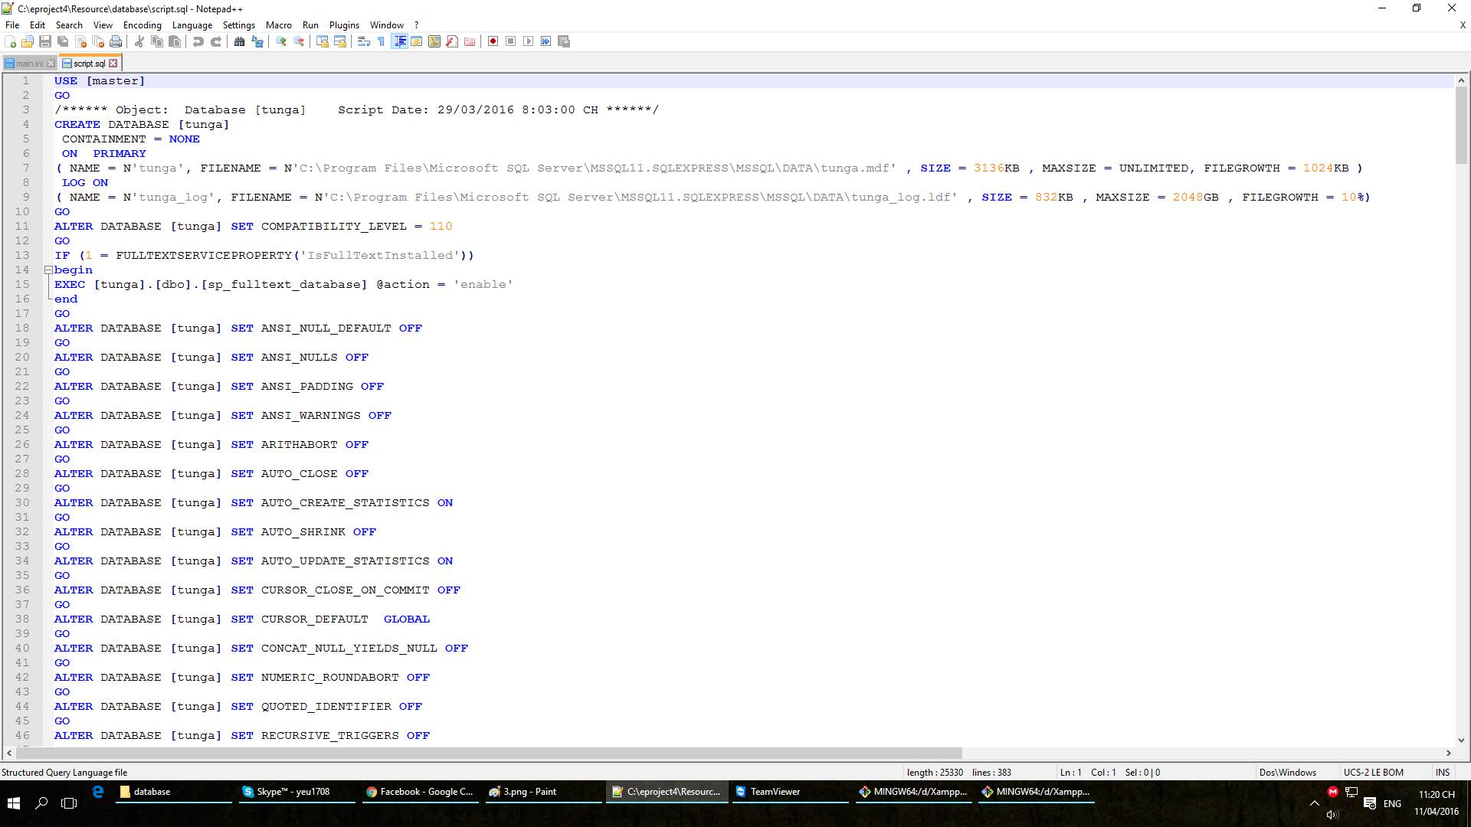

* If create successful, after **Refresh**, on list **Databases** will display database name is **tunga**

* 1. **Using project.**

1. Config your host for the server. Exam:

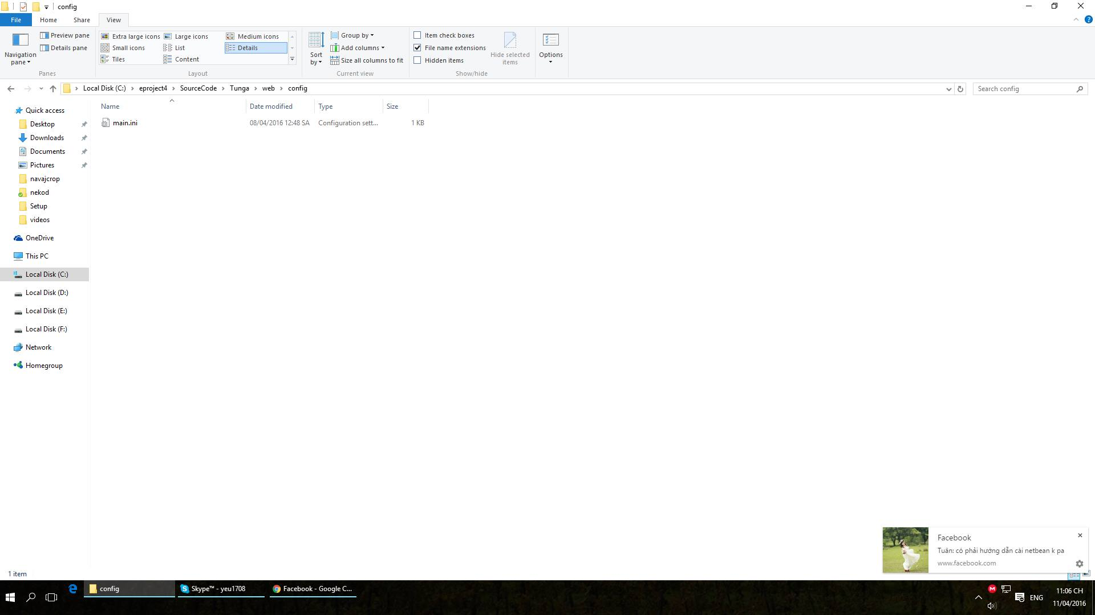

. The Client request to the server by host:

1. ***Client index.***



The index will be display:

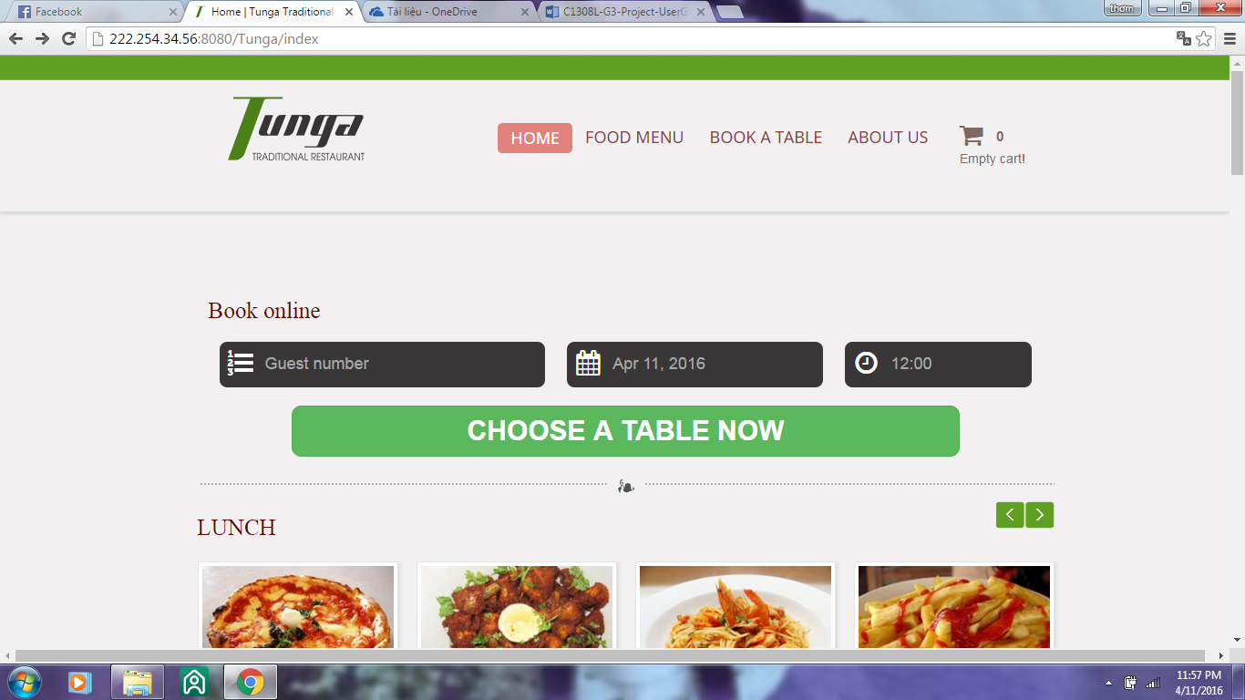

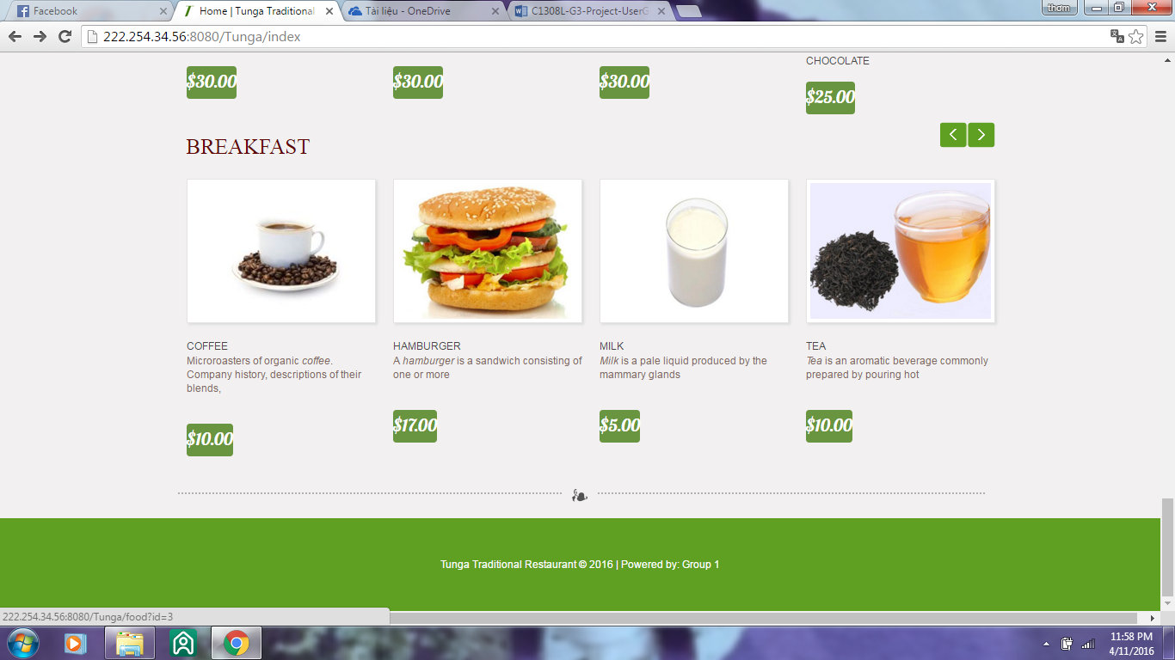

I**. Now, the guest can view the food and home delivery:**

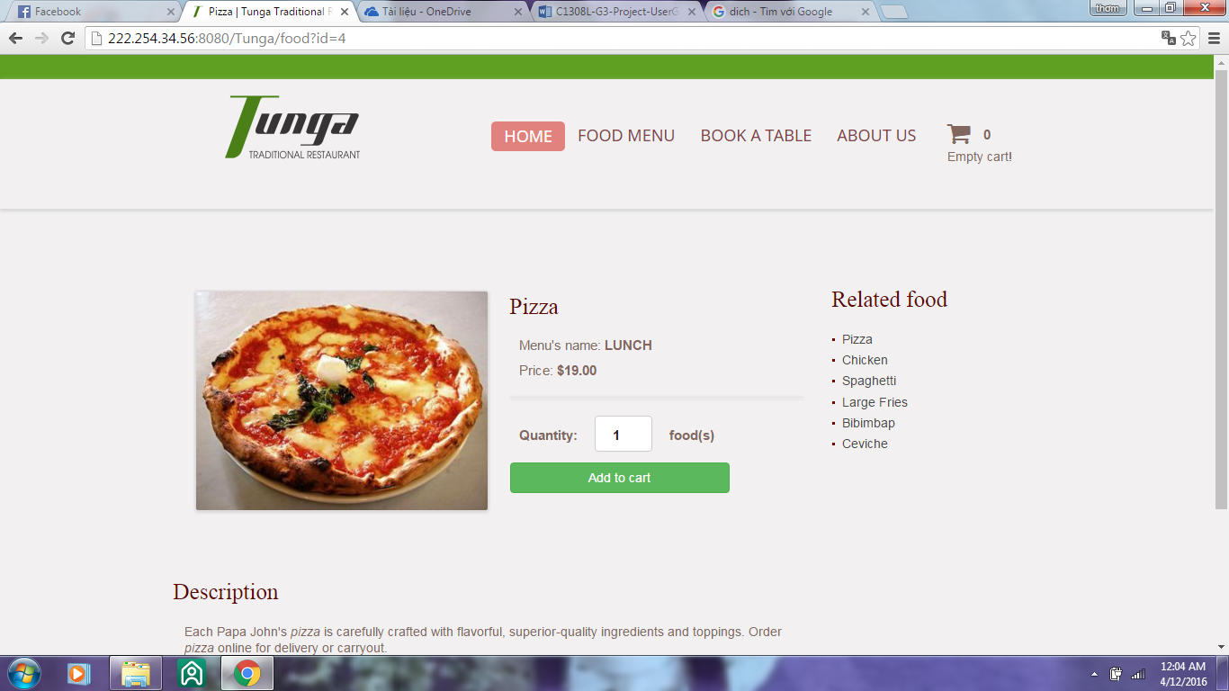

Click to button "Add to cart" to home delivery food. The shopping cart will be added the food.

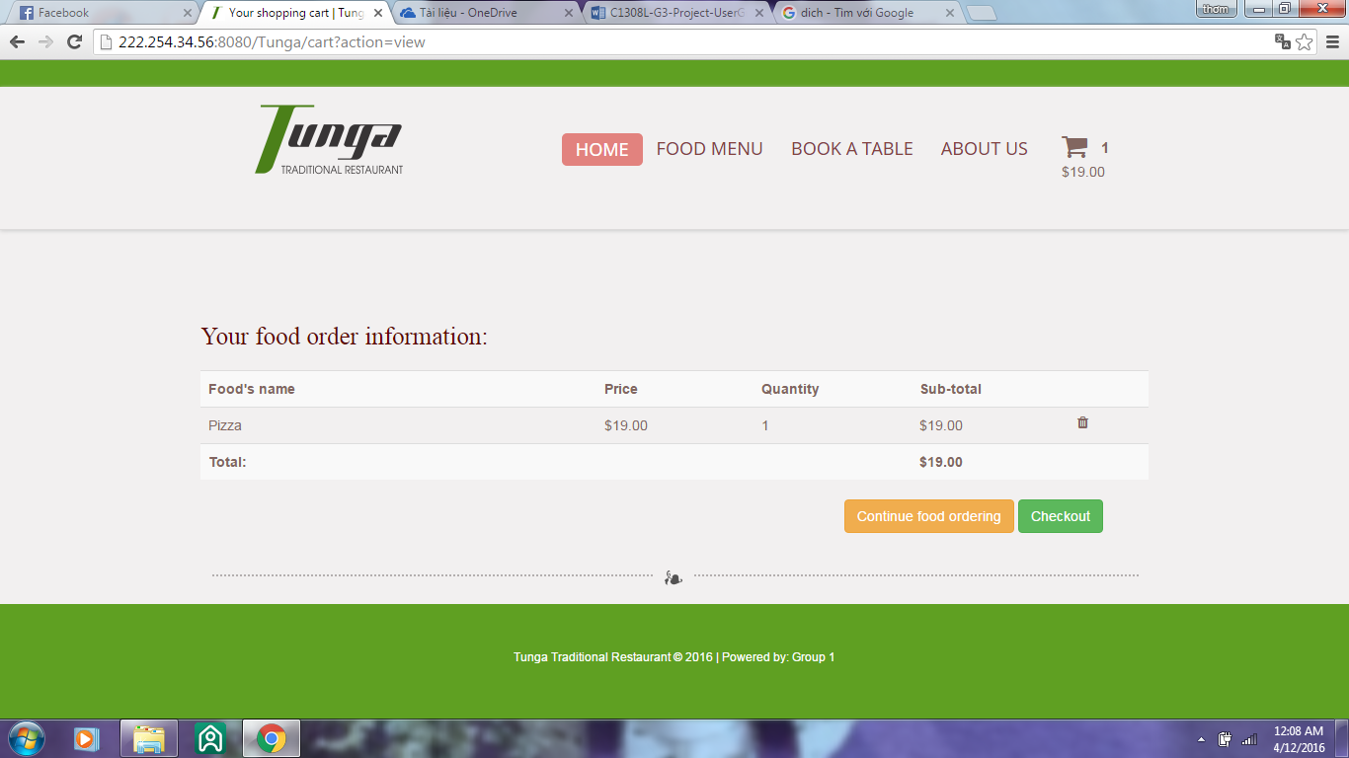

Now, you can continue food order by click" Continue food ordering"; or you can checkout here by click " Checkout". After click" Checkout", you need fill your information in all the textbox.

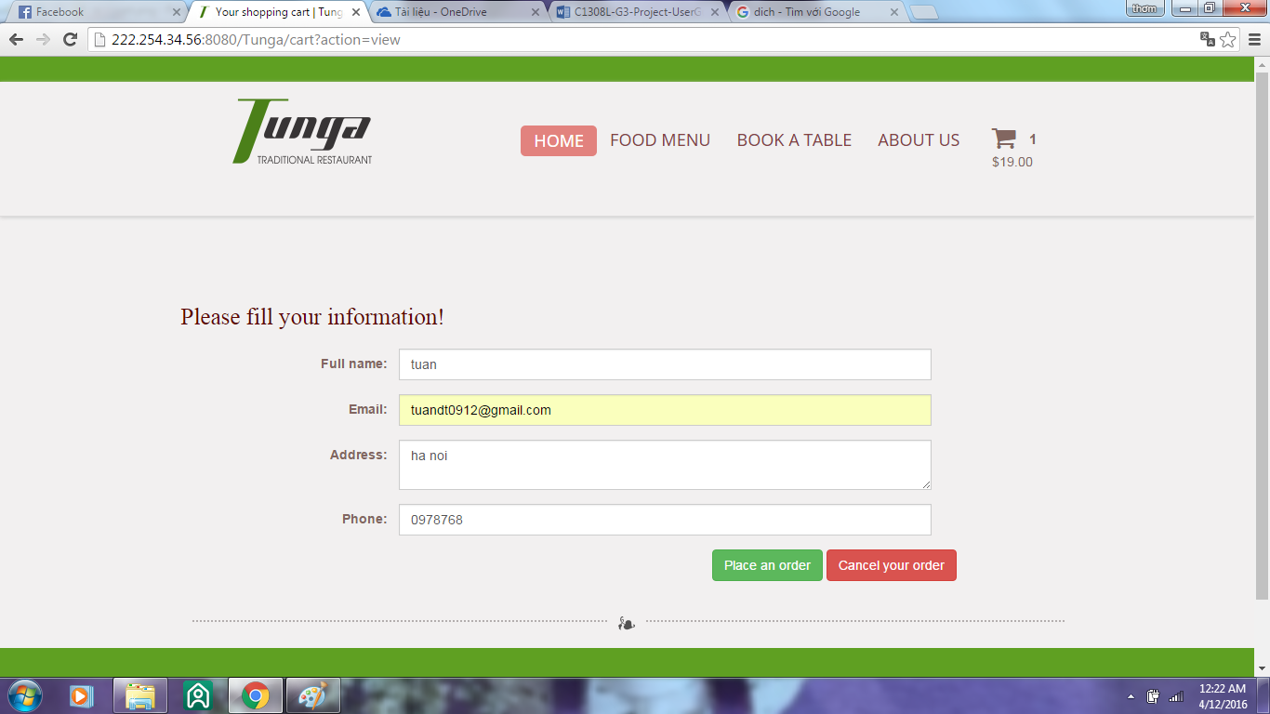

After fill all information you can confirm your order by click " Place and order" to give a token invoice.

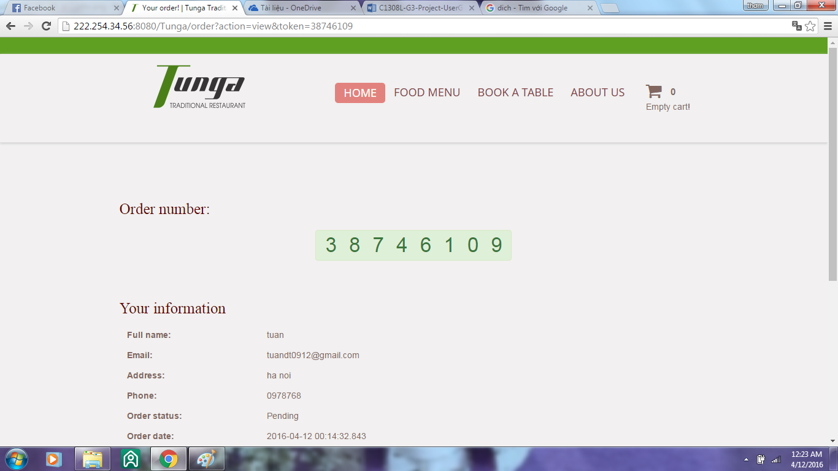

An otherway, you can cancel your order by Click "Cancel your order".

1. **Book a table.**

Click " **Book a table",**  a form will display:

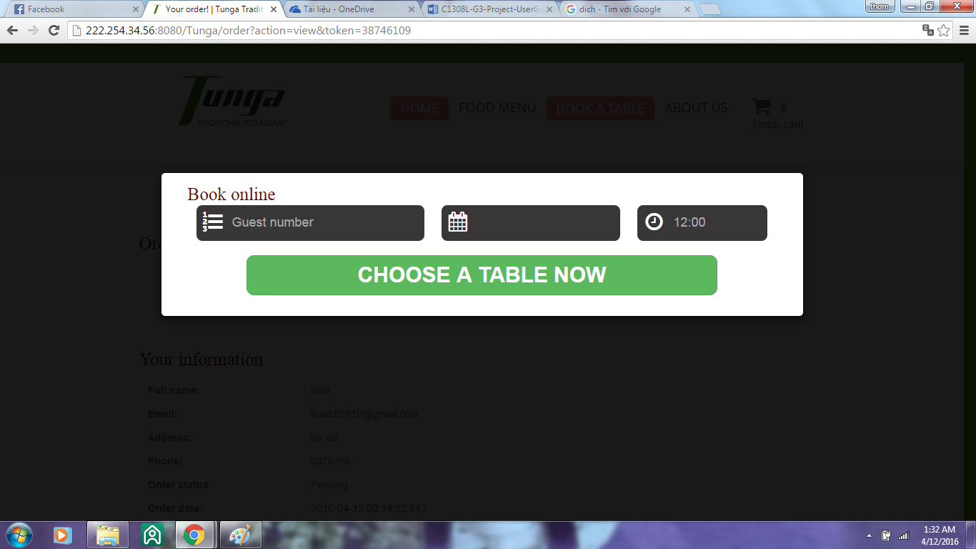

## Fill information to the form:

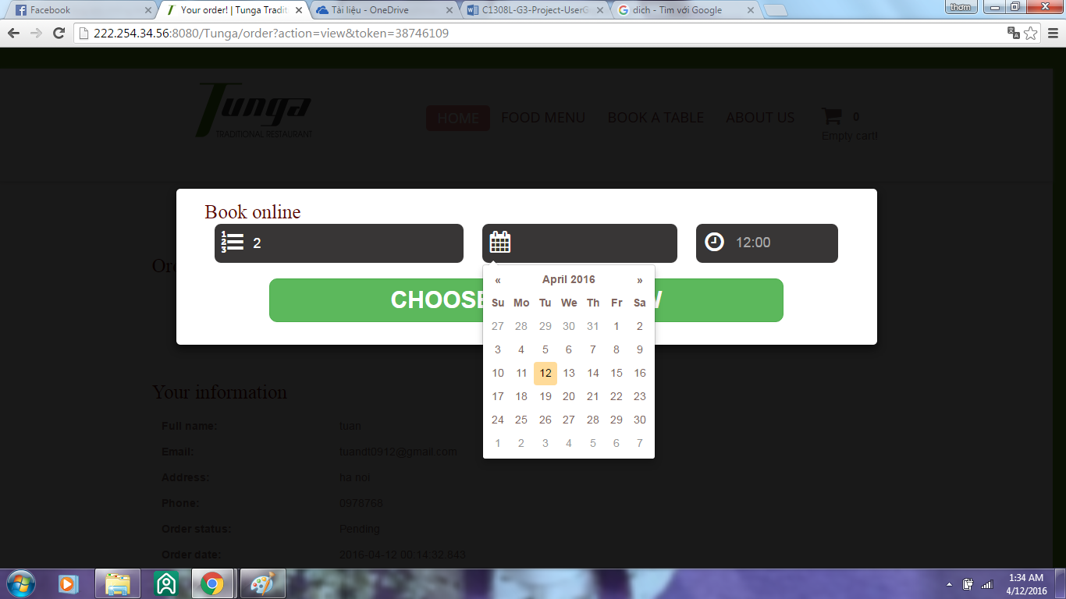

## List of free table will display:

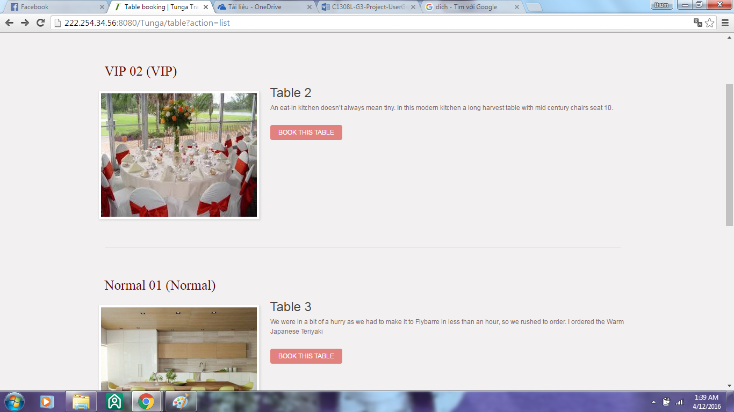

## Click " Book this table" to book the table you want.

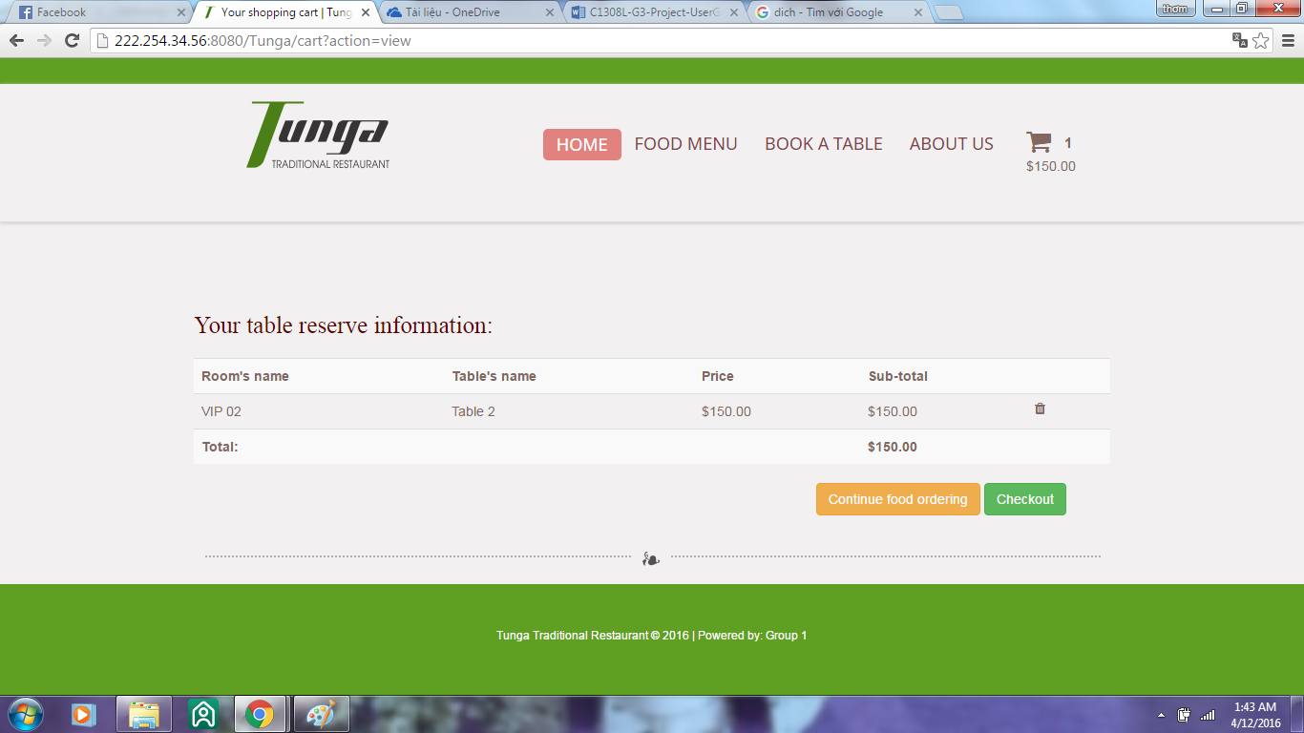

## Now checkout or order food.

***B. Admin system.***

***a. login with user"admin" and password"admin".***

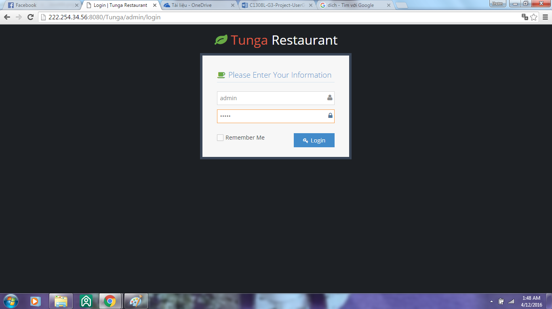

## The admin control display:

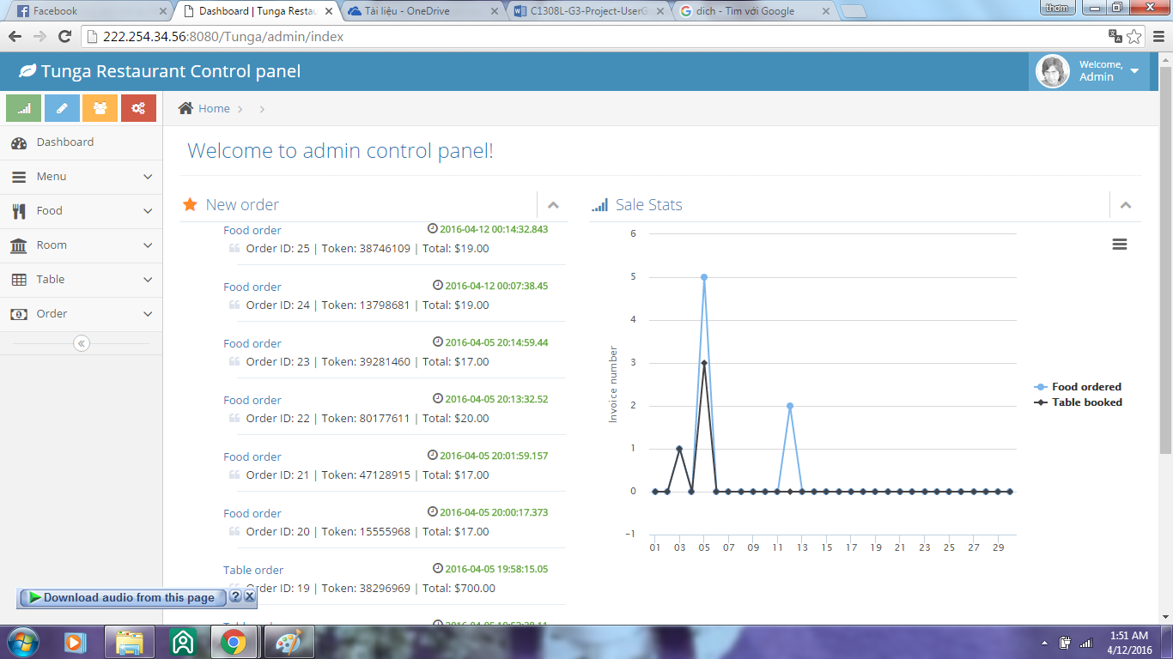

List menu:

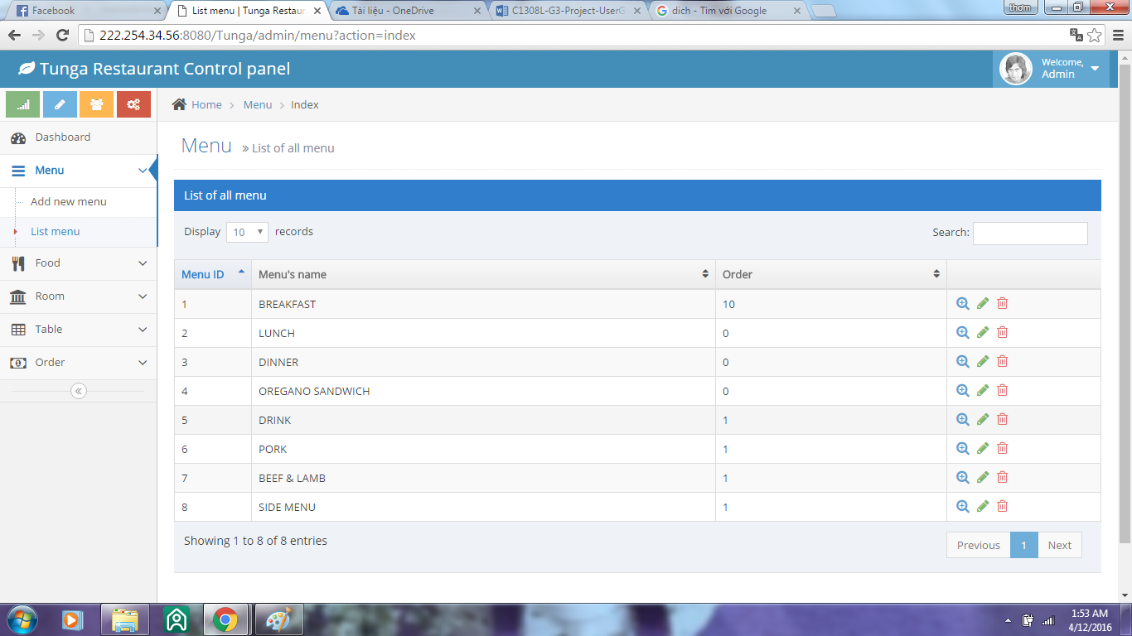

List food:

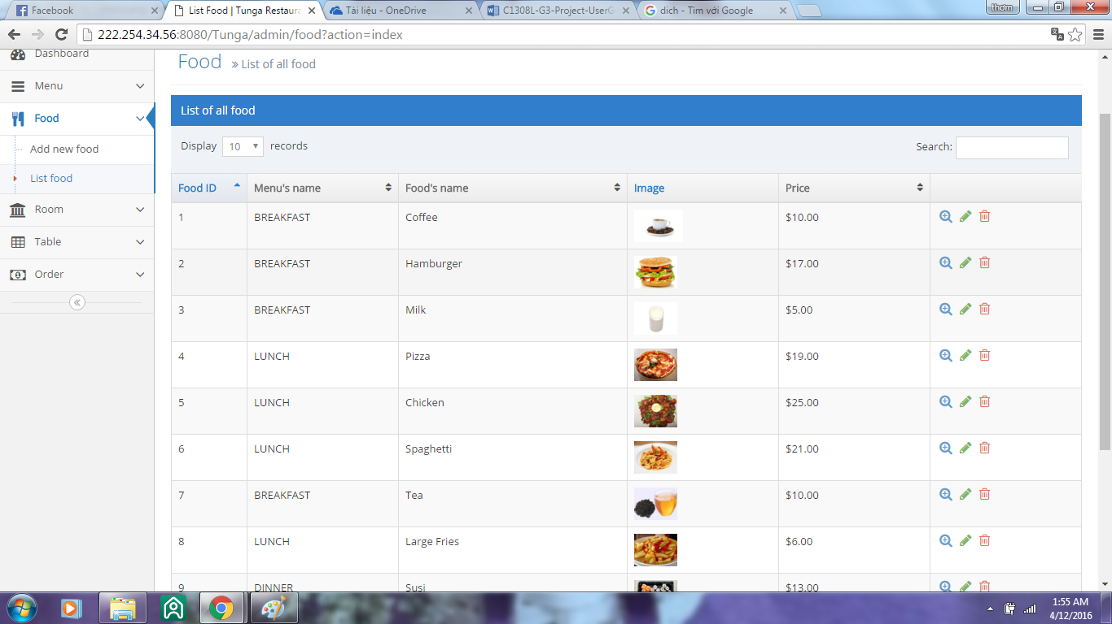

## List room:

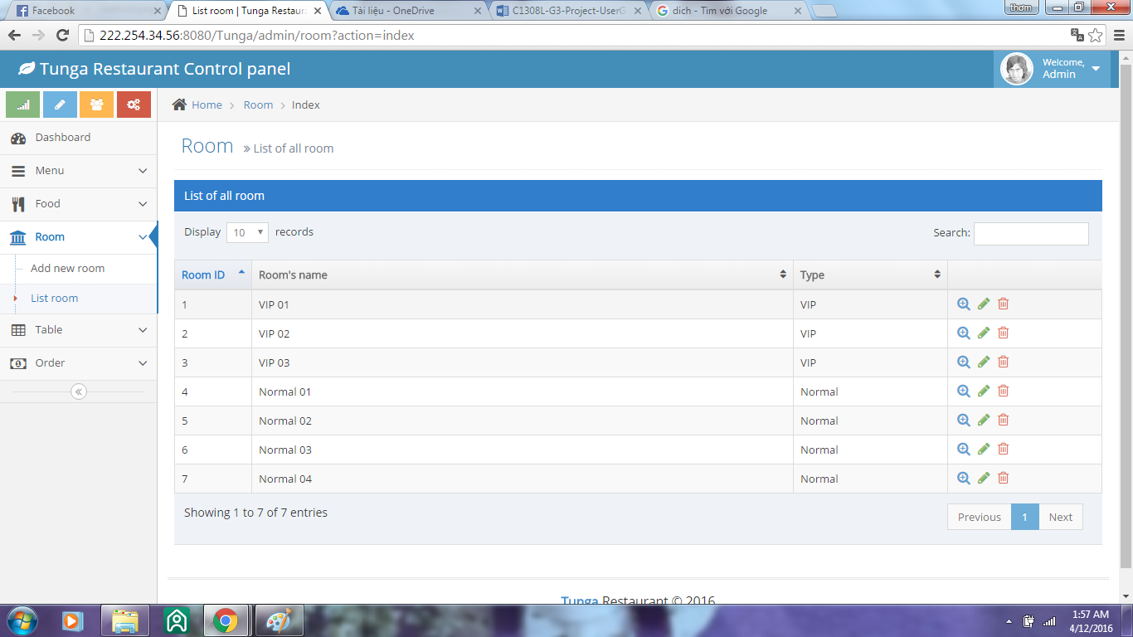

## 

## 

## List table:

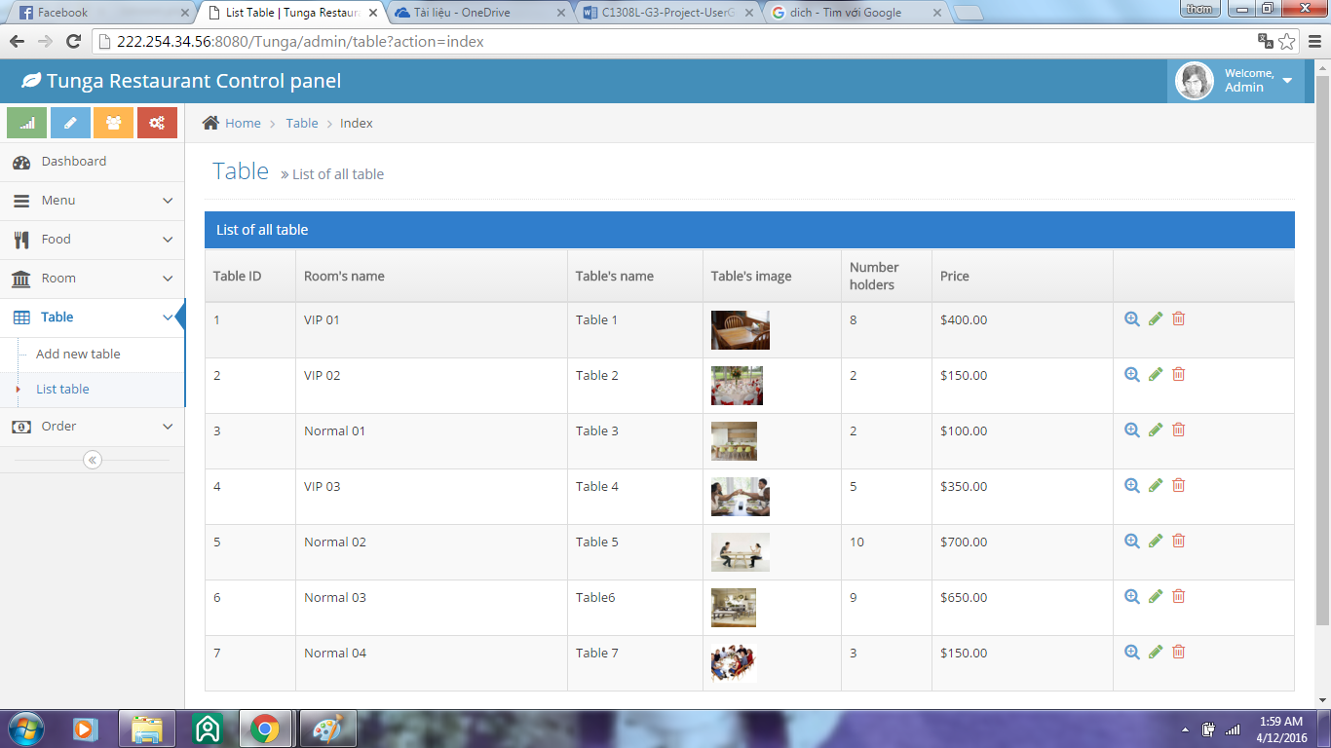

## List order:

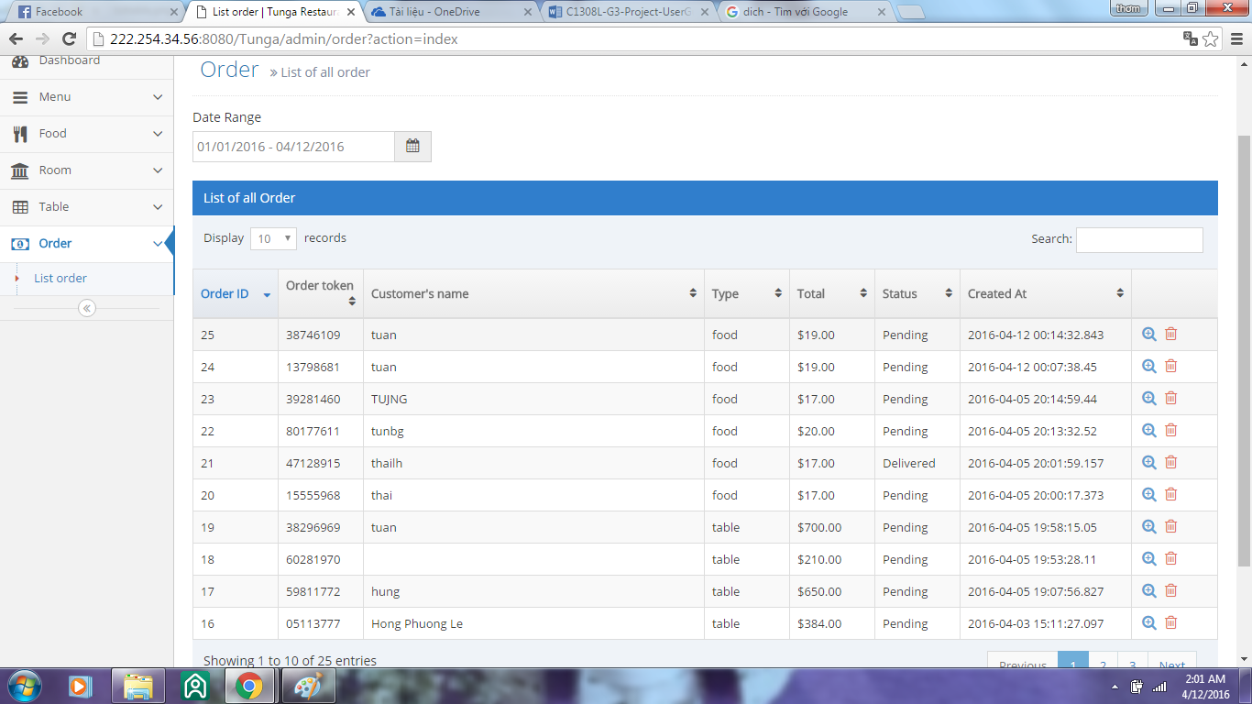

## Click " " to view information of order and then admin can change order's status.

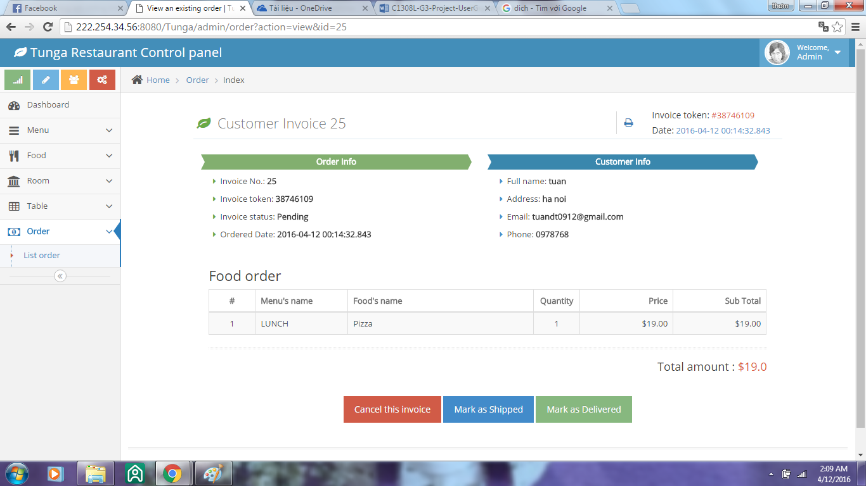

## Note: All of list table, room, food, menu admin can add new, update, delete.